1. INTRODUCTION

  - PROJECT DETAILS

The functions of Intelligence Bureau broadly include crime detection, crime prevention and law and order maintenance. All these functions are interlinked to each other, which depend on the flow of information amongst them.

Departmental hierarchy allows the reporting from bottom to top level with consolidation of reports at each level. Instructions pass from top to bottom whereas reporting is done from bottom to top. Crime Units are the places where crime related data is generated and sent upwards. In the hierarchy as one goes lower, information is more in details.

The Intelligence Bureau is divided in to many sub branches. Each Sub branch gathers information, investigates and tracks different kinds of crimes.
Currently Intelligence Bureau team works on the Past Experience faced by the senior officers. So all the decisions are taken by IB are truly according to the Image of the incident in the officers’ mind. The fact may be different in many cases.

This is so because they don’t have real facts of all the important incidents. They have to read Related Files for all the incidents and they are running sort of time. Even in many cases they don’t have related Physical files with them. Due to this they don’t have fact data with them. So all they can do is to take decisions with the Experience.

In addition to this, there is no scheme with the help of which they can have data reports generated automatically. This is to be done by hand which is next to impossible.

So these are the main disadvantage of the present system which is being followed by IB currently.

Another problem is that the superior authority, seating at the head quarter, can never see the status of the particular file unless he asks the relative local officer or he gets the Physical file in his hand.

To overcome these problems, IB Department needs an Integrated Automation System which connects all of the Police Stations where IB team has its representatives.

This System will gather all the data about the important incidents, organizations and people.

The System will generate Reports with the data it has. These reports will be very helpful in concluding the fact from the data.

The System will be able to take place of Physical files and thus removing the paper work.

Instead of physical file, the system will send the e-file to the authorities and to other departments when it’s necessary to forward a file in hierarchy.

PURPOSE

A study has been conducted to understand the current processes being followed by the Intelligence Bureau, through various standard-interviewing techniques like interviews, questionnaires, checklist, and role play with each responsible user of the functions of the main office. The results of this study showed that the current system of management of Intelligence Bureau requires all the forms, reports etc. to be generated manually. This requires a lot of hard work to be done by hand and hence a lot of time is also wasted.

The purpose of this project is to propose a new system for the work related to Intelligence Bureau. This will be the basis for the development and implementation of the computerized system for better efficiency, effective utilization of manpower, reduced repetitive processes and reporting systems, and above all, quicker decision making.

Requirement gathering of standard procedures, formats, forms, registers, reports and various other documents and business processes will enable us to understand, analyze and propose a new computerized system for better efficiency and efficacy. This will enable in effective and better utilization of manpower, better and improved reporting framework and processes with reduced repetitive work and faster decision making.

This project aims at computerizing the work done by the Intelligence Bureau. This requires development of forms, procedures, reports etc. which are till now maintained manually.

On completion of this project, the new system for the Intelligence Bureau will help it in better manpower and cost management and also in reducing repetitive work.

SCOPE

The purpose of this project is to mainly computerize the Intelligence Bureau Department. Hence this project is solely for the work done by the IB. Any other department is not covered in the scope of this project. Also the project is entirely based on user requirements as specified by the user and hence it is not possible to add any extra features apart from those provided by the user. Its scope is limited to the work done by the Intelligence Bureau Department.

1.4 OBJECTIVE
The branches of Intelligence Bureau do the following activities:
- Information Gathering
- Consolidation Activities
- Forecasting (Analysis Activities)
- Record Maintenance Activities
- Reporting Activities

IB is the main coordinating authority regarding security, law and order situation with the Centre and other states. Hence, the Head office is interlinked with information flow of all kinds of activities and events related to political, communal, religious, elections, students, unions, farmers, laborers, foreigners, Pakistan nationals, airport, ports and coastal areas of the state and security related information through these various support units. Work allocation for above activities is distributed to the branches situated at the head office of the Intelligence Bureau.

IB has identified the provision of online and instantaneous access to information. The proposed solution includes the following
- Building up of Master Data for various applications
- Re-using the data across various applications thereby reducing the data-redundancy and duplication of work.

1.5 TECHNOLOGY AND LITERATURE REVIEW

- Eclipse
To build complete enterprise level applications, developers need more than Java. Oracle believes strongly, and has invested heavily, in the combination of Java, SQL, and XML. Java is used for programming the business and presentation logic, SQL for interacting with the database, and XML for passing information between loosely coupled applications.
- As MVC Architecture was used, Java Developer Eclipse helps developers build an enterprise level application using Java, XML, HTML, SQL, and PL/SQL and provides various code editors and visual tools for each of these languages.
- To maximize developer productivity, Eclipse provides a comprehensive set of integrated tools that support the complete development lifecycle, from source control, modeling, and coding through debugging, testing, profiling, and deploying. Eclipse simplifies J2EE development by providing wizards, editors, visual design tools, and deployment tools to create high-quality, standard J2EE components including applets, JavaBeans, Java Server Pages (JSP), Servlets, and Enterprise JavaBeans (EJB).

- MySQL Query Browser
MySQL Query Browser is an Integrated Development Environment that is specifically targeted at the development of stored program units for Oracle Databases. Over time more and more business logic and application logic has moved into the Oracle Server, so that MySQL Query Browser has become a significant part of the total development process. MySQL Query Browser focuses on ease of use, code quality and productivity, key advantages during Oracle application development.

- Tomcat Server 5.0.28
- The Apache Software Foundation provides support for the Apache community of open-source software projects. The Apache projects are characterized by a collaborative, consensus based development process, an open and pragmatic software license, and a desire to create high quality software that leads the way in its field.
- Apache Tomcat is the servlet container that is used in the official Reference Implementation for the Java Servlet and Java Server Pages technologies.
- Apache Tomcat is developed in an open and participatory environment and released under the Apache Software License. Apache Tomcat is intended to be a collaboration of the best-of-breed developers from around the world.
- Apache Tomcat powers numerous large-scale, mission-critical web applications across a diverse range of industries and organizations.

Advantages of Tomcat Server:
- Performance optimizations and reduced garbage collection
- Refactored application deployer, with an optional standalone deployer allowing validation and compilation of a web application before putting it in production
- Complete server monitoring using JMX and the manager web application
- Scalability and reliability enhancements
- Improved Taglibs handling, including advanced pooling and tag plugins
- Improved platform integration, with native Windows and Unix wrappers
- Embedding using (Java Management Extension) JMX
- Enhanced Security Manager support
- Integrated session clustering

- J2EE
As J2EE is a combination of several technologies that offer cohesiveness to bond together server side systems and services and produce an industrial-strength scalable environment within which web-centric applications can thrive.
- J2EE simplifies the creation of an enterprise-wide application, because functionality is encapsulated in components of J2EE.
- This enables designers and programmers to organize the application into functionality that is distributed across the server-side components built using J2EE.
- Moreover J2EE contains all the interfaces and libraries that is required for handling complex programs of multithreading and synchronization.
- J2EE is a Multi-Tier Architecture (to be precise four tier architecture). These consist of Client Tier, Web Tier, Business Tier, and Enterprise Information Tier.

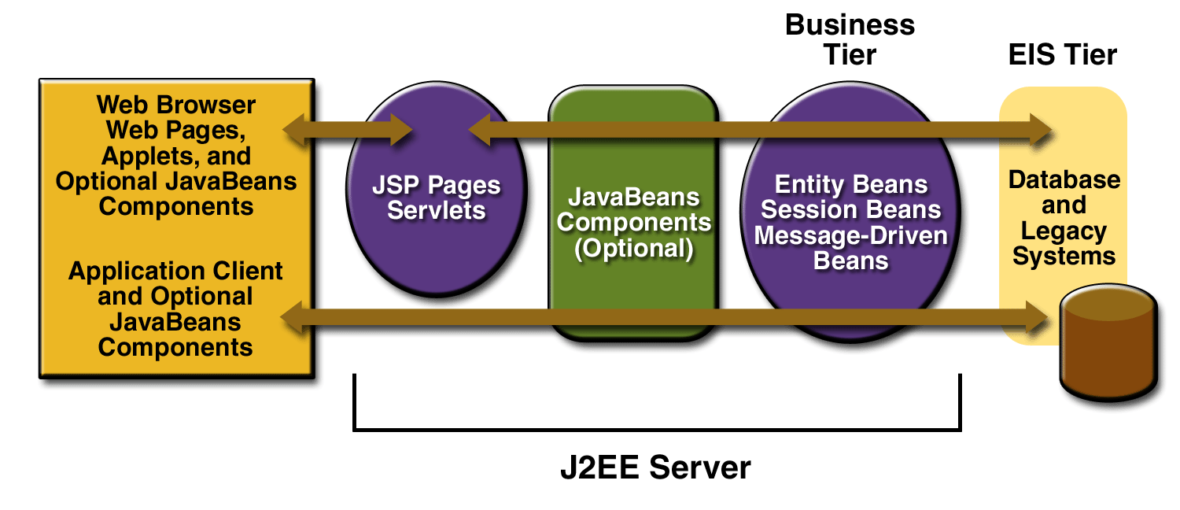
Fig 1.5.1 J2EE Technologies

- The J2EE platform uses a multi-tiered distributed application model. Application logic is divided into components according to function, and the various application components that make up a J2EE application are installed on different machines depending on the tier in the multi-tiered J2EE environment to which the application component belongs
  - Client-tier components run on the client machine.
  - Web-tier components run on the J2EE server.
  - Business-tier components run on the J2EE server.
  - Enterprise information system (EIS)-tier software runs on the EIS server.
  - Hibernate is a powerful, high performance object/relational persistence and query service.
  - Hibernate relieves the developer from 95 percent of common data persistence related programming tasks, compared to manual coding with SQL.
  - Hibernate can map entities and particular properties to SQL expressions.

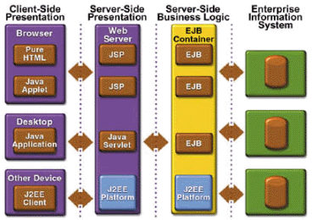
Fig 1.5.2 J2EE Multi-tier Distributed Application Model

- hibernate
Below are some of the reasons as why hibernate is used extensively:-
    - Natural programming model.
    - No build-time byte code enhancement .
    - Extreme scalability.
    - The query options.
    - Free/open source.

- Hibernate Overview:

Architecture

The System follows a popular MVC-2 (Model-view-Controller) architecture. MVC architecture calls for a visual application to be broken up into three separate parts:
                - A model that represents the data for the application.
                - The view that is the visual representation of that data.

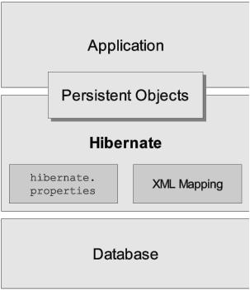
Fig 1.5.3 Hibernate Model

                - A controller that takes user input on the view and translates that to changes in the model.
                - The goal of the MVC-2 design pattern is to separate the application object (model) from the way it is represented to the user (view) from the way in which the user controls it (controller).
                - In the System, the Browser and the JSP pages comprise the View.
                - The Front Servlet is the single controller for the system which identifies the different parameters and transfers the control to the appropriate request handlers.
                - The Request Handlers, Business Objects and the Data Access Objects comprise the Model part.
                - The Request Handlers process the business logic of the requests.

  - Spring Framework
                - Spring is essentially a technology dedicated to enabling you to build applications using Plain Old Java Objects (POJOs).
                - It enables you to develop components as POJOs containing only your business logic, while the framework takes care of the many value adds you need to build enterprise applications — even in areas that you may not have considered when initially authoring the application.
                - This goal requires a sophisticated framework, which conceals much complexity from the developer. Because your business logic is abstracted from infrastructure concerns, it’s also likely to enjoy a longer life, improving the return on investment of writing it.
                - Business logic should change at the pace of your business; only if it is abstracted from infrastructure concerns can the impact on your code base of inevitable infrastructure change (such as choice of application server) be minimized.

  - MICROSOFT VISUAL SOURCE SAFE

Microsoft Visual Source Safe is a version control tool, basically used for proper and efficient maintenance of the project related documents. All the documents that are delivered by various vendors at various phases of testing are maintained through this tool.

There is a facility to provide access rights in this tool. So only the team members’ specific to project can access the documents related to their projects. No other person, other than the team members has access rights to it.

Hence it helps managing the projects, regardless of the file type (text files, graphics files, binary files, sound files, or video files) by saving them to a database. When we need to share files between two or more projects, we can share them quickly and efficiently. When we add a file to VSS, the file is backed up on the database, made available to other people, and changes that have been made to the file are saved so we can recover an old version at any time. Members of team can see the latest version of any file, make changes, and save a new version in the database.

VSS project organization makes team coordination easy and intuitive for more information on projects.
When a file (or set of files) is ready to deliver to another person, group, Web site, or any other location, VSS makes it easy to share and secure different versions of the selected set of files.

Before adding files to the VSS database, there should be a project to place the files in. When working with VSS, the first thing to do is create one or more projects. After the project has been created, files or folders can be added to the VSS database
Some of the facilities provided are listed below:
                - Branching: In VSS, one file can be shared among multiple projects. Changes to the file from one project are automatically seen by other projects sharing the file. This encourages code reuse. Branching is the process of taking a file in two directions (that is, branches or paths) at once. VSS keeps track of these branches by tracking the different paths as a project.

Branching, a file breaks the shared link, making the file in that project independent of all other projects. The changes made in the file are not reflected elsewhere, and vice versa. A branch has been created: two files (the file in the project and its counterpart in other projects) have a shared history up to a certain point and divergent histories after that time.
                - Checkout: To make changes to a file you must first check it out of the VSS database. When we Checkout an item, VSS places a writ able copy in the working folder. A file that is checked out cannot be checked out by anyone else unless your installation of VSS has been set up to allow multiple checkouts. It can be known who is working on which file currently. We can check out one file, multiple files, or all files in a project depending on what item(s) we have selected when we perform the checkout operation. In addition to checking out an item, we can also View or Get the item.
                - Check In: When a file is checked out, check in replaces the updated file or project with current copy of VSS, thus storing your changes in the current project in VSS.
                - Undo: the checkout, canceling the changes made both in VSS and in the working folder — the file or project returns to the way it was before being checked it out.
                - Version control: VSS can maintain multiple versions of a file, including a record of the changes to the file from version to version.

Coding Architecture

MVC architecture calls for a visual application to be broken up into three separate parts:
  - A model that represents the data for the application.
  - The view that is the visual representation of that data.
  - A controller that takes user input on the view and translates that to changes in the model.
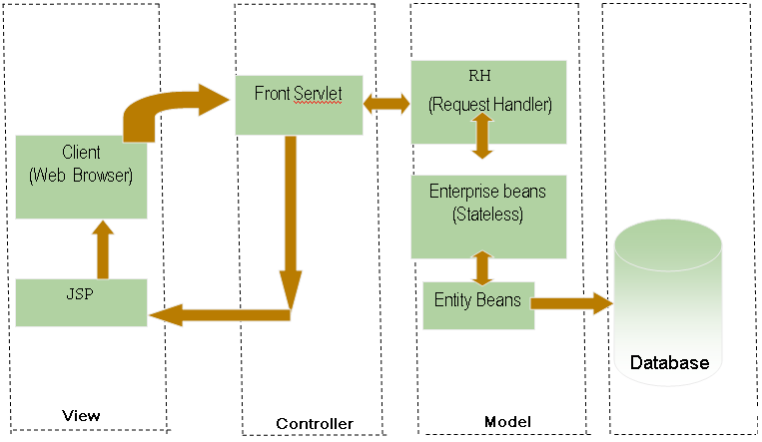
Fig 1.5.4 MVC Architecture
The solution architecture has three layers:
- Presentation layer:
This layer enables navigation, manipulation and translation onto the users' desktops.
- Application layer:
This layer consists of an application server and a web server, both handled by the J2EE application, and a mail server for messaging and workflow in order to provide a collaborative environment.
- Data layer:
This layer consists of structured data in the Oracle RDBMS, and unstructured documents and textual information in J2EE application.
The MVC architecture has the following benefits:
- Multiple views using the same model:
The separation of model and view allows multiple views to use the same enterprise model. Consequently, an enterprise application's model components are easier to implement, test, and maintain, since all access to the model goes through these components.
2) Easier support for new types of clients:
To support a new type of client, you simply write a view and controller for it and wire them into the existing enterprise model.
3) Clarity of design:
By glancing at the model's public method list, it should be easy to understand how to control the model's behavior. When designing the application, this trait makes the entire program easier to implement and maintain.
- Efficient modularity:
Modularity of the design allows any of the components to be swapped in and out as the user or programmer desires - even the model! Changes to one aspect of the program aren't coupled to other aspects, eliminating many nasty debugging situations. Also, development of the various components can progress in parallel, once the interface between the components is clearly defined.
- Ease of growth:
Controllers and views can grow as the model grows; and older versions of the views and controllers can still be used as long as a common interface is maintained.
- Distributable:
With a couple of proxies one can easily distribute any MVC application by only altering the startup method of the application.
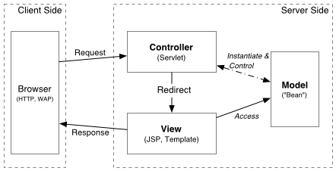
Fig 1.5.5 MVC 2 Architecture

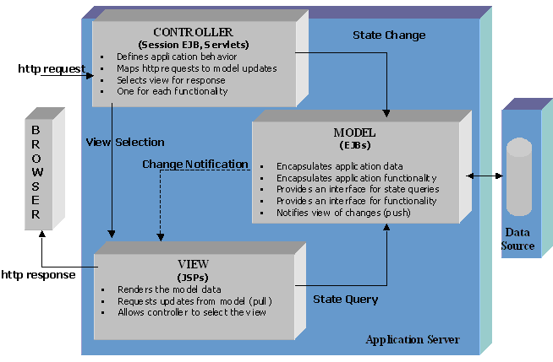
Fig 1.5.6 MVC 2 Architecture
- MVC 2 Architecture.

JSP pages in a Model 1 application that use scripting elements, custom tags, or JavaScript to forward requests should be re-factored to Model 2.
Model 1 architecture is best when the page navigation is simple and fixed, and when a simple directory structure can represent the structure of the pages in the application. Such applications usually embed the page flow information in the links between the pages. The presence of forward in a JSP page implies that logic embedded in the page is making a decision about the next page to display.
Over time, as the application grows and changes, page flow logic accumulates. The application becomes difficult to maintain because the page flow logic is distributed across multiple pages. The best time to switch from Model 1 to Model 2 is before this maintenance problem arises. This is why it's usually best to choose Model 2 from the outset, basing the application on an existing Web controller framework that best meets application requirements. Model 1 remains a viable option for simple, static applications.
To build complete enterprise level applications, developers need more than Java. Oracle believes strongly, and has invested heavily, in the combination of Java, SQL, and XML. Java is used for programming the business and presentation logic, SQL for interacting with the database, and XML for passing information between loosely coupled Applications.

As MVC model 2 Architecture was used, XML, HTML and SQL provide various code editors.

Also, AJAX, and Hibernate were used in some common functionalities of the project.

Three things are required for the execution of a new service:
- DAO
- Service
- Value Object(VO)
DAO:
- In DAO an interface is made in which all the methods will be declared.
- DAOImpl is created which is an implementation of the declared interface, in which all the methods that are declared in DAO are present.
- The HQL query is made in this implementation file only.
Service:
- In service, an instance of DAOImpl is made with the help of which the appropriate method of DAOImpl is called.
Value Object:
- The Value Object has a map which contains the mapping between the values that come from JSP page and the values are forwarded to the service.

Execution of a New Service:
- Initially the JSP page will set the action flag and it will transfer the control to the Controller.
- If action flag refers to a method of service then the Controller will fetch the data related to that action flag from the database and will call the VOGEN or Service based on sequence of execution.
- The service will call the DAOImpl associated with that service and in turn DAOImpl will call the ValueObject which in turn refers to the appropriate table of the database.
- In reverse order when data is retrieved from the database, VO will return the data to the DAOImpl which in turn will pass the data to the service which will pass the data to the appropriate JSP Page.
- All the data which is to be passed from one file to another should be passed in Map only.
- For captions in the jsp file, a properties file is created, which contains all the captions present in the jsp file. Separate properties file is created for each language. Each properties file has the actual caption in that particular language, stored against a common caption id.

IITSIB SOA using Spring and Hibernate

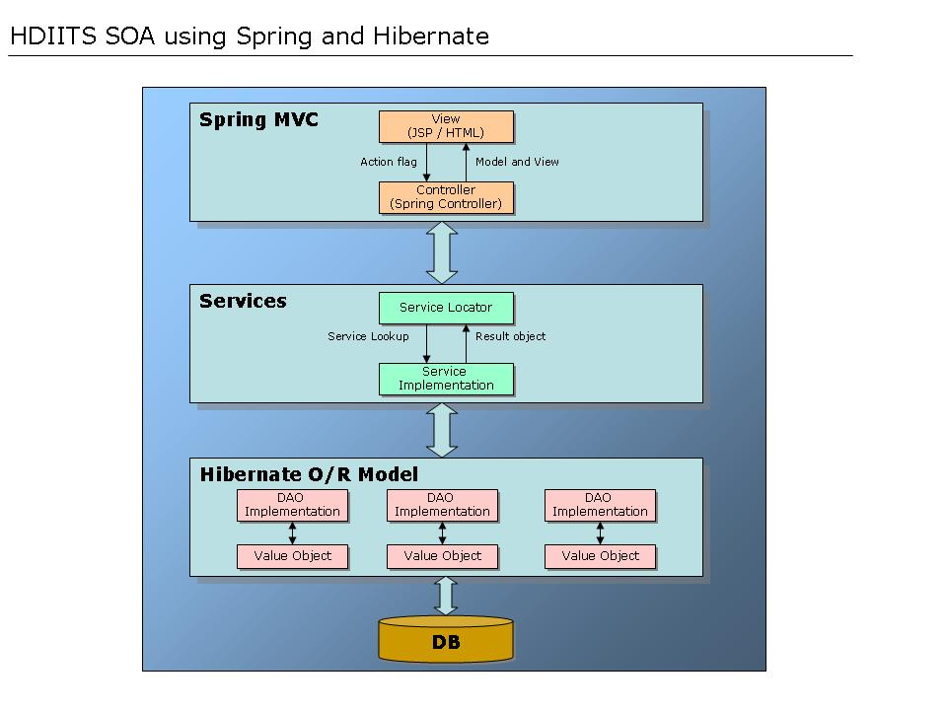
Fig 1.5.7 ITSIB SOA Using Spring and Hibernate

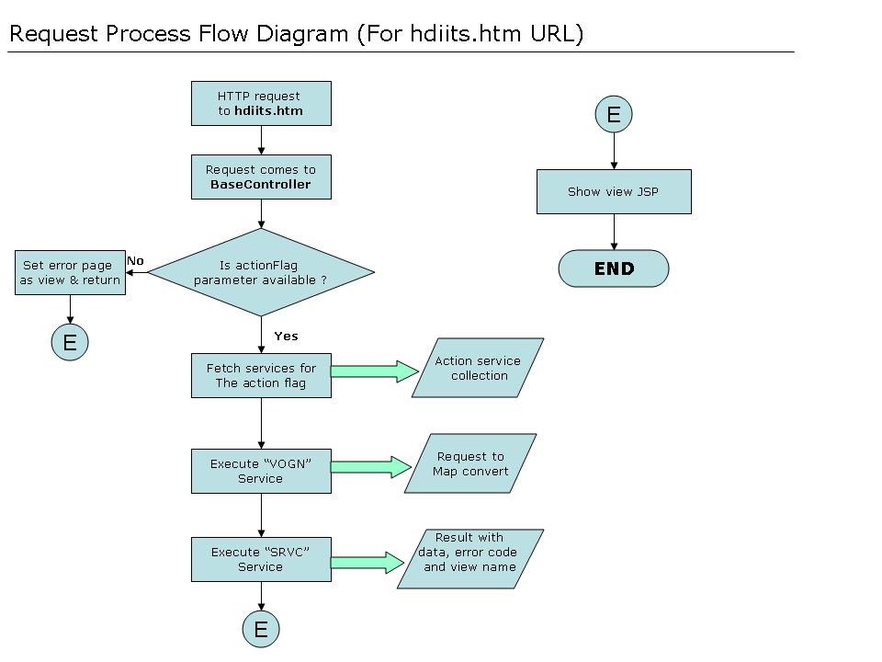

Fig 1.5.8 ITSIB flow of the process

